**Building Automated** Ecommerce application using Docker

* Logged into AWS using private credentials
* Selected the EC2 from Services Menu
* Selected the AWS EC2 instance type t2. Medium
* Attached pre-created relevant subnet and security groups



* Created EC2 instance

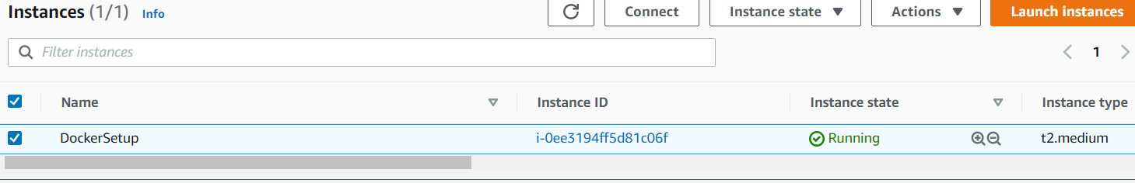

* Followed below mentioned steps to install Docker
  + - Connected instance through SSH

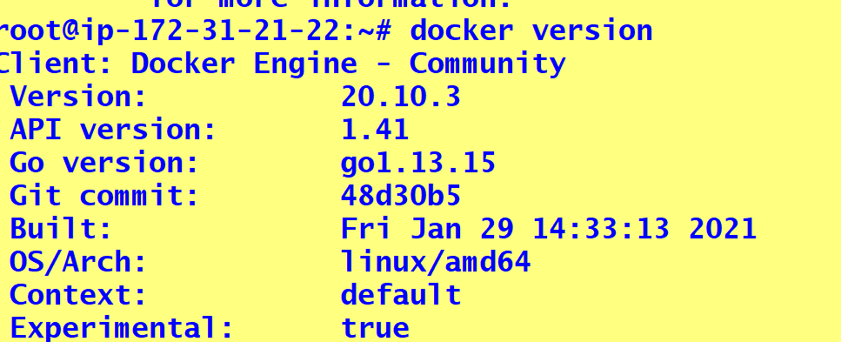

* Installed git and maven using the command 🡺 apt-get install -y git maven

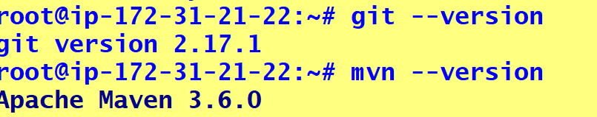

* Executed the following commands to complete docker installation
  + curl -fsSL https://get.docker.com -o get-docker.sh
  + # $ sh get-docker.sh
* Pushed the respective code base to Git hub with following commands



https://github.com/vekagithub/eComAppAutomation.git

* Applied git clone to EC2



* **Installed docker compose with below command 🡺**
* **sudo curl -L "https://github.com/docker/compose/releases/download/1.26.2/docker-compose-$(uname -s)-$(uname -m)" -o /usr/local/bin/docker-compose**
* **set the permission sudo chmod +x /usr/local/bin/docker-compose**



Prepared the Docker-compose.yml with below script

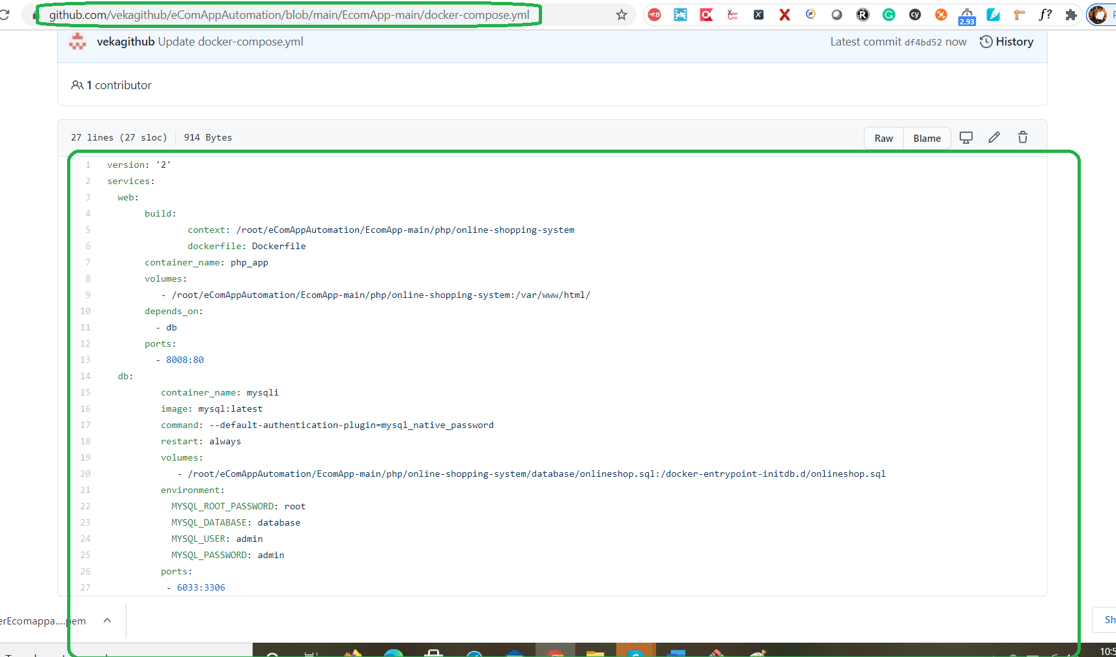

Ran the above prepared docker compose file

docker-compose.yml

docker-compose up -d

docker container ls

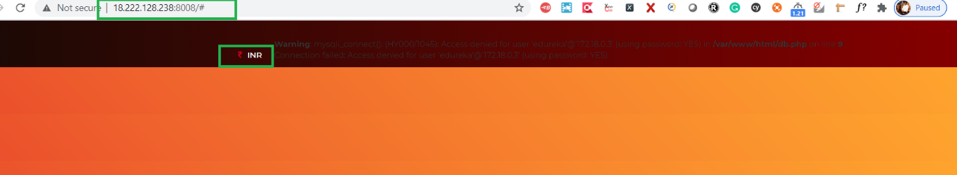

docker container ls

docker commit 90edb75ff5b0 8897131402/ecompoc

docker image ls

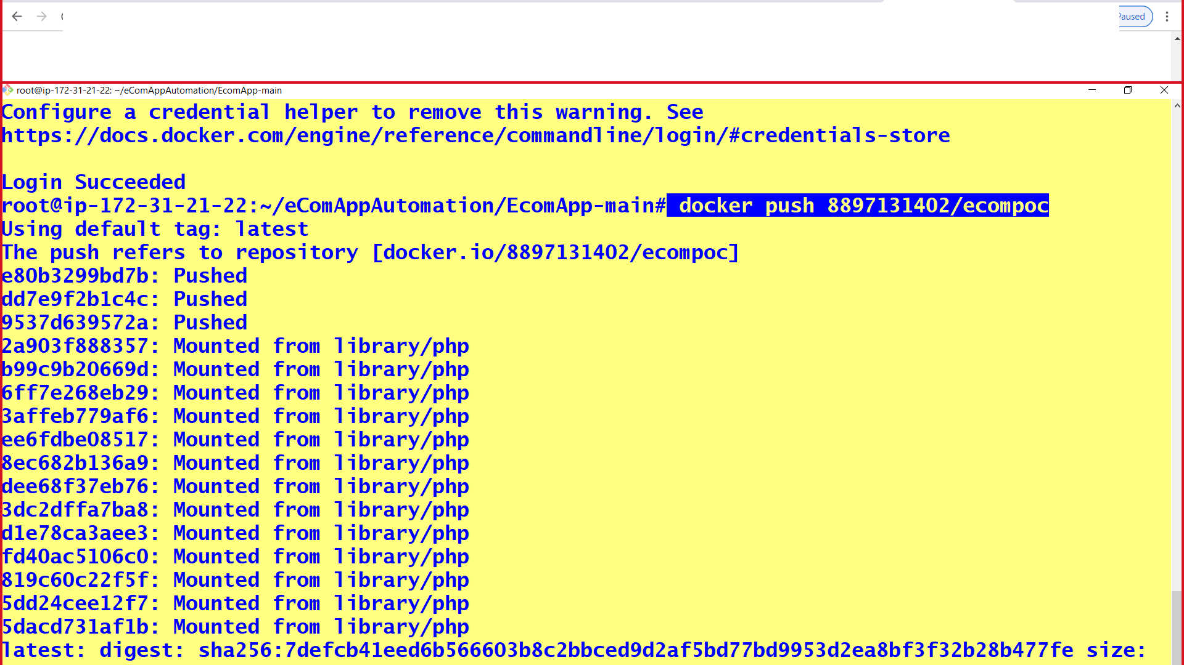

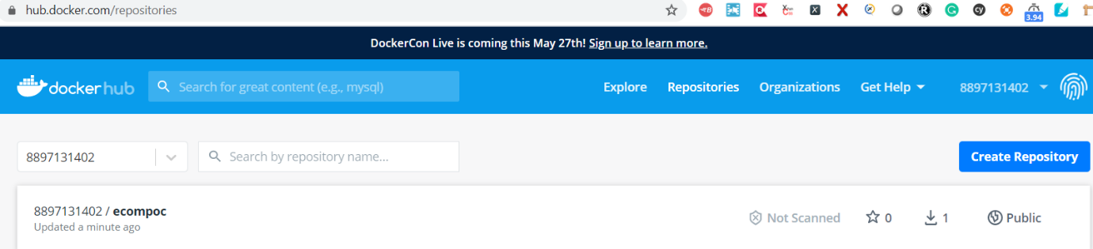

Successfully pushed the image from container to Docker hub @ hub.docker.com/repositories